Letter of application
https://prezi.com/dmwaid3cj4ql/writing-a-cae-letter/?utm_campaign=share&utm_medium=copy

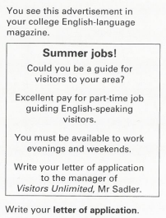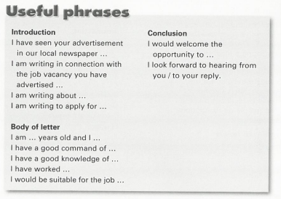

Model answer
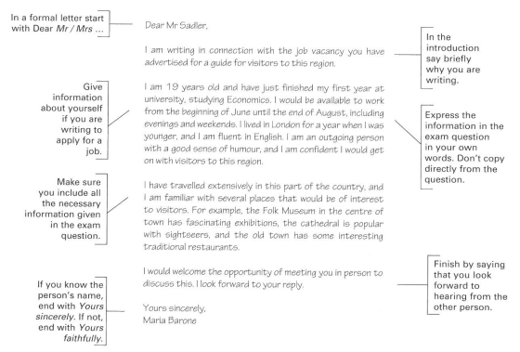

An application letter

- No address!
- No subject line!
- Formal language
- Paragraphs

Structure is important:
- greeting: Dear Sir or Madam, / Dear Mr/Mrs __________ (name)
- Paragraph 1, why you are writing:
  - example: I noticed / saw your advertisement… and am writing to apply …
  - see more examples below
  - always include where you saw the advertisement
- Body of the letter
  - your life experience
- why you are interested in the job + why you are the right person for the job
- what you are sending with the letter, when you can start work
- Closing phrase:
  - example: I look forward to hearing from you soon.
  - see more examples below
- Yours faithfully (if you start Sir or Madam), Yours sincerely (if you use a specific name)

Useful phrases
feel free to change the phrases to your liking (if possible)

Salutation
- Dear Sir or Madam, (If you do not know their name.)
- Dear Mr Jones, / Dear Mrs Smith, (If you are given their name, you MUST use it, but NOT their first name)

Reasons for writing the letter of application
- I am writing to apply for the post/position of … as advertised in …
- I am writing in response to your advertisement which I saw …
- I am writing in connection with your advertisement in the Daily Star on May 11th …

Reasons for applying for the job
- I like working with ________ and I would enjoy the challenge of _________
- I have just finished school and in October I will be starting a degree course in _______ I am therefore very keen to gain experience in _________.
- I feel I have the necessary _______ and I would be interested in __________
- to make a positive and enthusiastic contribution to your _______ and

Interests / Skills / Experience
- I gained some experience while …
- I am currently working as …
- I have been working for … for the last four years.
- I worked part-time for three years as …
- At the moment I am employed by …
- My qualifications include …
- I have a diploma in …
- I graduated from Barcelona University last year with a degree in …
- My interests include ____

Attachments
- Please find attached my CV
- As you can see from the attached CV …
- I am enclosing my CV, the letters of reference …

Ending the letter
- I hope you will consider my application favourably.
- I am available for an interview at any time.
- Please do not hesitate to contact me if you require further information.
- I am available for an interview at your convenience.
- I shall be available for an interview any day apart from Wednesdays.
- I would welcome the opportunity of meeting you in person.
- If you require any further information, please do not hesitate to contact me.
- Thank you for considering my application.
- You may include the phrases above but THESE ARE A MUST:
  - I look forward to hearing from you.
  - I look forward to receiving your reply.

Signing off
- Yours faithfully (If you have written “Dear Sir / Madam”)
- Yours sincerely (If you have written “Dear Mr Jones”)

https://www.eslprintables.com/writing_worksheets/writing_letters/letter_of_application/Letter_of_application_350206/

